MACMH 2022
Handout ©JI Consults from How Much Is Too Much Leaders Guide by Jean Illsley Clarke.
Permission to reproduce for educational purposes.

My

MY CHILDS HIGHWAY
You can
think before you say yes or no and learn from your mistakes.

Structure- 6 -12 year-old
Adolescent’s Name______________________________Age_______

You can
trust your
intuition to
help you
decide what
to do.

Childs | Adult’s
Temperament | Temperament
Health | Health
Situation | Situation
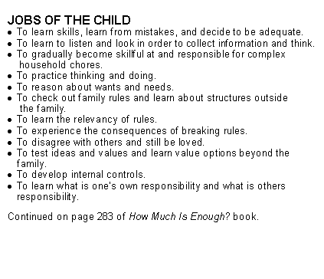
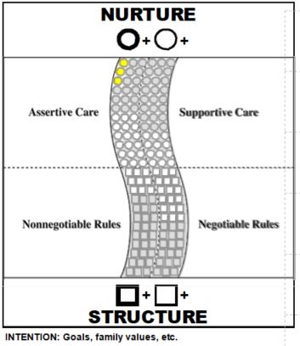
I love you
even when
we differ;
I love
growing
with you.

You can
think for
yourself and
get help
instead of
staying
in distress.

You can learn when and how to disagree
You can
learn the rules that help you live with others.

You can
find a way of doing things that works for you
Handout ©JI Consults from How Much Is Too Much Leaders Guide by Jean Illsley Clarke.
Permission to reproduce for educational purposes.

For more information please contact Lisa Krause lisa@parentcoachconnection.com
763-438-1093
www.parentcoachconnection.com

